 | The Aldhelm Mission Fund Application  Form A | 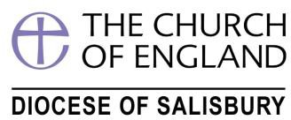

This form should only be used for funding applications up to £500 in total.
It should be completed electronically and emailed to the Fund Secretary (see below).

Applicant's Details

Name:

Address:

Email:

Telephone:

Sponsor’s Details

Sponsoring Parish or Deanery:

Incumbent/Church Warden or Rural Dean/Lay Chair:

Details of Project

Please give brief details of the intended project, the dimensions of outreach, how you will judge success and the intended management structure. Please keep this succinct. About 200 words should cover the main points.

What applications are being made to other sources of funding?

This form should only be used for grants up to £500 (five hundred pounds). Amount Requested:
Please provide account details (Account name, number and sort code) that should be used in the event of the application being successful.

The Trustees retain the right to ask the project management team for progress reports at pre-arranged intervals.

Signed: Date:

Please return to the Aldhelm Mission Fund Secretary via steve.inglis@salisbury.anglican.org

Note: Form A should only be used for funding applications up to £500 in total. All other applications should be made using Form B.

Please note that it is unlikely that you will be offered financial assistance if your Parish Share is in arrears unless a repayment plan has been agreed with the Diocesan Board of Finance

